Geometric Condition

Definition
# Source: AI Source: Provided by: [Data Path: Persons Table -> ID Column: 1, Name_En Column: Motasem Essam] -> From: [ChatGPT] on [7/25/2026]
A Geometric Condition is a mathematical requirement or relationship that a geometric object, point, line, angle, segment, or figure must satisfy.
It describes what must be true about a geometric configuration.
A geometric condition can involve:
- distances,
- lengths,
- angles,
- positions,
- incidence,
- equality,
- parallelism,
- perpendicularity,
- ratios,
- areas,
- intersections,
- or other geometric relationships.
$$\boxed{\text{Geometric Condition}=\text{Requirement that must be satisfied by a geometric object}}$$

Simple Definition
# Source: AI Source: Provided by: [Data Path: Persons Table -> ID Column: 1, Name_En Column: Motasem Essam] -> From: [ChatGPT] on [7/25/2026]
A geometric condition is a rule that specifies a required geometric relationship or property.
For example:
$$PA=5$$
is a geometric condition stating that point $P$must be exactly $5$units from point $A$.

Fundamental Concept
# Source: AI Source: Provided by: [Data Path: Persons Table -> ID Column: 1, Name_En Column: Motasem Essam] -> From: [ChatGPT] on [7/25/2026]
A geometric condition tells us which geometric configurations are allowed.
For a moving point $P$, the condition determines the possible positions of $P$.
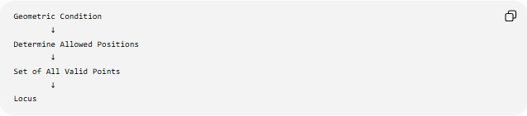
Geometric Condition
↓
Determine Allowed Positions
↓
Set of All Valid Points
↓
Locus
For example:
$$PA=5$$
gives:
$$\boxed{\text{Circle centered at }A\text{ with radius }5}$$
because every point on that circle satisfies the condition.

Main Types of Geometric Conditions
# Source: AI Source: Provided by: [Data Path: Persons Table -> ID Column: 1, Name_En Column: Motasem Essam] -> From: [ChatGPT] on [7/25/2026]
A practical classification is:
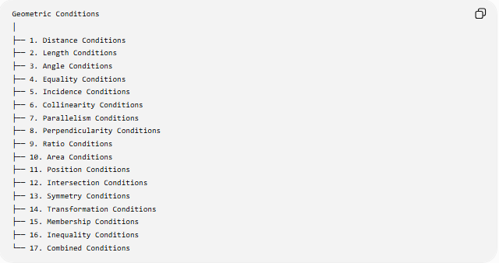
Geometric Conditions
│
├── 1. Distance Conditions
├── 2. Length Conditions
├── 3. Angle Conditions
├── 4. Equality Conditions
├── 5. Incidence Conditions
├── 6. Collinearity Conditions
├── 7. Parallelism Conditions
├── 8. Perpendicularity Conditions
├── 9. Ratio Conditions
├── 10. Area Conditions
├── 11. Position Conditions
├── 12. Intersection Conditions
├── 13. Symmetry Conditions
├── 14. Transformation Conditions
├── 15. Membership Conditions
├── 16. Inequality Conditions
└── 17. Combined Conditions
These are practical/descriptive categories; some conditions naturally belong to more than one category.

1. Distance Conditions
# Source: AI Source: Provided by: [Data Path: Persons Table -> ID Column: 1, Name_En Column: Motasem Essam] -> From: [ChatGPT] on [7/25/2026]
Definition
A distance condition specifies a required distance between geometric objects.
Example
$$PA=5$$
means that $P$must be $5$units from $A$.
The corresponding locus is:
$$\boxed{\text{Circle centered at }A\text{ with radius }5}.$$
Another example:
$$PA=PB$$
means $P$must be equally distant from $A$and $B$.
The locus is:
$$\boxed{\text{Perpendicular bisector of }AB}.$$

2. Length Conditions
# Source: AI Source: Provided by: [Data Path: Persons Table -> ID Column: 1, Name_En Column: Motasem Essam] -> From: [ChatGPT] on [7/25/2026]
A length condition specifies a required length or relationship between lengths.
Example
$$AB=10\text{ cm}.$$
This requires segment $AB$to have length $10$cm.
Another example:
$$AB=CD.$$
This requires:
$$\boxed{∣AB∣=∣CD∣}.$$
Length conditions are common in geometric construction and triangle problems.

3. Angle Conditions
# Source: AI Source: Provided by: [Data Path: Persons Table -> ID Column: 1, Name_En Column: Motasem Essam] -> From: [ChatGPT] on [7/25/2026]
An angle condition specifies a required angle measure or relationship between angles.
Example
$$∠ABC={60}^{∘}.$$
This requires the angle at $B$to measure ${60}^{∘}$.
Another example:
$$∠A=∠B.$$
This requires the two angles to be equal.
A fixed-angle locus can be written:
$$\boxed{∠APB=θ}.$$
For fixed $A,B,θ$, this leads to an appropriate circular arc.

4. Equality Conditions
# Source: AI Source: Provided by: [Data Path: Persons Table -> ID Column: 1, Name_En Column: Motasem Essam] -> From: [ChatGPT] on [7/25/2026]
An equality condition requires two geometric quantities to be equal.
Examples:
$$\boxed{AB=CD} \\ \boxed{∠A=∠B} \\ \boxed{PA=PB} \\ \boxed{A_{1}=A_{2}}$$
where the quantities might represent lengths, angles, areas, distances, or other measurements.
Example
$$PA=PB$$
is both:
- a distance condition, and
- an equality condition.
This illustrates that geometric conditions can overlap.

5. Inequality Conditions
# Source: AI Source: Provided by: [Data Path: Persons Table -> ID Column: 1, Name_En Column: Motasem Essam] -> From: [ChatGPT] on [7/25/2026]
A geometric condition does not have to be an equality.
It can specify a greater-than or less-than relationship.
Examples:
$$\boxed{PA<5} \\ \boxed{PA>PB} \\ \boxed{∠A>∠B} \\ \boxed{AB<CD}.$$
Example
$$PA<5$$
does not produce the circle itself.
Instead, it describes the points inside the circle of radius $5$centered at $A$.
$$\boxed{PA<5→\text{open disk}}$$
while:
$$\boxed{PA=5→\text{circle}}.$$

6. Incidence Conditions
# Source: AI Source: Provided by: [Data Path: Persons Table -> ID Column: 1, Name_En Column: Motasem Essam] -> From: [ChatGPT] on [7/25/2026]
Definition
An incidence condition specifies that a geometric object belongs to, lies on, passes through, or intersects another object.
Examples
$$\boxed{P∈l}$$
means point $P$lies on line $l$.
$$\boxed{A∈\overset{‾}{BC}}$$
means $A$lies on segment $BC$.
$$\boxed{P∈C}$$
means $P$lies on circle $C$.
These conditions often directly define a locus.

7. Parallelism Conditions
# Source: AI Source: Provided by: [Data Path: Persons Table -> ID Column: 1, Name_En Column: Motasem Essam] -> From: [ChatGPT] on [7/25/2026]
A parallelism condition requires two lines to be parallel.
For example:
$$\boxed{l_{1}∥l_{2}}.$$
If a line through a fixed point $P$must be parallel to a given line $l$, then the direction of the constructed line is determined.
Example
Through point $P$, construct a line parallel to $l$:
$$\boxed{m∥l, P∈m}.$$
This is a geometric construction condition.

8. Perpendicularity Conditions
# Source: AI Source: Provided by: [Data Path: Persons Table -> ID Column: 1, Name_En Column: Motasem Essam] -> From: [ChatGPT] on [7/25/2026]
A perpendicularity condition requires two objects to meet at a right angle.
$$\boxed{l_{1}⊥l_{2}}$$
means:
$$\boxed{∠\left(l_{1} , l_{2}\right)={90}^{∘}}.$$
Example
If:
$$P∈l$$
and:
$$AP⊥l,$$
then $P$is the foot of the perpendicular from $A$to $l$.
Perpendicularity conditions are fundamental in:
- perpendicular bisectors,
- altitudes,
- shortest-distance problems,
- right triangles,
- projections.

9. Ratio Conditions
# Source: AI Source: Provided by: [Data Path: Persons Table -> ID Column: 1, Name_En Column: Motasem Essam] -> From: [ChatGPT] on [7/25/2026]
A ratio condition specifies a fixed relationship between two or more quantities.
Example
$$\boxed{\frac{PA}{PB}=2}.$$
This means the distance from $P$to $A$is twice its distance from $B$.
Unlike:
$$PA=PB,$$
the locus is generally not a straight perpendicular bisector.
For fixed points $A,B$, a constant ratio:
$$\boxed{\frac{PA}{PB}=k}$$
with $k≠1$produces an Apollonius circle in the plane.
When:
$$k=1,$$
the locus becomes the perpendicular bisector of $AB$.

10. Area Conditions
# Source: AI Source: Provided by: [Data Path: Persons Table -> ID Column: 1, Name_En Column: Motasem Essam] -> From: [ChatGPT] on [7/25/2026]
An area condition specifies an area requirement.
Example
$$\boxed{\left[△ABC\right]=20}$$
means the area of triangle $ABC$must be $20$square units.
For fixed base $AB$, since:
$$K=\frac{1}{2}AB⋅h,$$
a fixed area determines a fixed altitude.
Therefore, possible positions of the third vertex $C$lie on lines parallel to $AB$at the appropriate distance.

11. Position Conditions
# Source: AI Source: Provided by: [Data Path: Persons Table -> ID Column: 1, Name_En Column: Motasem Essam] -> From: [ChatGPT] on [7/25/2026]
A position condition restricts where a point or object may be located.
Examples:
$$\boxed{P\text{ lies inside }△ABC} \\ \boxed{P\text{ lies above line }l} \\ \boxed{P\text{ lies to the right of }l} \\ \boxed{P\text{ lies between }A\text{ and }B}.$$
These conditions are often used to create restricted loci.

13. Symmetry Conditions
# Source: AI Source: Provided by: [Data Path: Persons Table -> ID Column: 1, Name_En Column: Motasem Essam] -> From: [ChatGPT] on [7/25/2026]
A symmetry condition requires a geometric object to have a particular symmetry.
Examples:
Reflection symmetry
$$\boxed{\text{Figure is invariant under reflection across }l}$$
Rotational symmetry
$$\boxed{\text{Figure is invariant under rotation by }θ}$$
Central symmetry
$$\boxed{P↔P^{'}}$$
with a common midpoint at the center of symmetry.
Symmetry conditions are frequently used in geometric constructions and proofs.

14. Transformation Conditions
# Source: AI Source: Provided by: [Data Path: Persons Table -> ID Column: 1, Name_En Column: Motasem Essam] -> From: [ChatGPT] on [7/25/2026]
A transformation condition specifies how one geometric object relates to another under a transformation.
Examples:
Translation
$$\boxed{P^{'}=P+\vec{v}}$$
Rotation
$$\boxed{P^{'}=R_{θ}\left(P\right)}$$
Reflection
$$\boxed{P^{'}={Ref}_{l}\left(P\right)}$$
Dilation
$$\boxed{OP^{'}=k OP}.$$
These conditions can define corresponding positions of geometric objects.

15. Combined Conditions
# Source: AI Source: Provided by: [Data Path: Persons Table -> ID Column: 1, Name_En Column: Motasem Essam] -> From: [ChatGPT] on [7/25/2026]
Several geometric conditions can be imposed simultaneously.
For example:
$$\boxed{PA=PB}$$
and:
$$\boxed{PC=5}.$$
The first condition gives the perpendicular bisector of $AB$.
The second gives a circle centered at $C$.
Therefore the solution is:
$$\boxed{L=L_{1}∩L_{2}}$$
where:
$$L_{1}=\text{perpendicular bisector of }AB$$
and:
$$L_{2}=\text{circle centered at }C\text{ with radius }5.$$
The final possible positions are their common points.

Geometric Condition → Locus
# Source: AI Source: Provided by: [Data Path: Persons Table -> ID Column: 1, Name_En Column: Motasem Essam] -> From: [ChatGPT] on [7/25/2026]
This is one of the most important relationships in locus geometry.
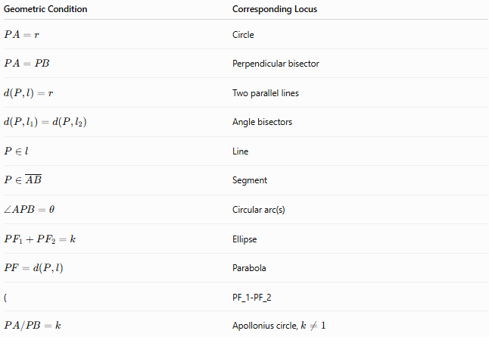
Geometric Condition | Corresponding Locus
$$PA=r$$ | Circle
$$PA=PB$$ | Perpendicular bisector
$$d\left(P , l\right)=r$$ | Two parallel lines
$$d\left(P , l_{1}\right)=d\left(P , l_{2}\right)$$ | Angle bisectors
$$P∈l$$ | Line
$$P∈\overset{‾}{AB}$$ | Segment
$$∠APB=θ$$ | Circular arc(s)
$$PF_{1}+PF_{2}=k$$ | Ellipse
$$PF=d\left(P , l\right)$$ | Parabola
( | PF_1-PF_2
$$PA/PB=k$$ | Apollonius circle, $k≠1$

Necessary vs Sufficient Conditions
# Source: AI Source: Provided by: [Data Path: Persons Table -> ID Column: 1, Name_En Column: Motasem Essam] -> From: [ChatGPT] on [7/25/2026]
A geometric condition can also be analyzed logically.
Suppose:
$$PA=PB.$$
For the perpendicular bisector $L$:
Necessity
If:
$$P∈L,$$
then:
$$PA=PB.$$
Sufficiency
If:
$$PA=PB,$$
then:
$$P∈L.$$
Therefore:
$$\boxed{PA=PB ⟺ P\text{ lies on the perpendicular bisector of }AB}$$
This is why the perpendicular bisector is the complete locus.

Geometric Condition vs Locus
# Source: AI Source: Provided by: [Data Path: Persons Table -> ID Column: 1, Name_En Column: Motasem Essam] -> From: [ChatGPT] on [7/25/2026]
These are different concepts.
Geometric Condition
The requirement:
$$\boxed{PA=5}.$$
Locus
The set satisfying that requirement:
$$\boxed{\text{Circle centered at }A\text{ with radius }5}.$$
Locus Construction
The process of producing that circle.
Therefore:
$$\boxed{\text{Condition}→\text{Locus}→\text{Construction}}$$

Geometric Condition vs Restriction
# Source: AI Source: Provided by: [Data Path: Persons Table -> ID Column: 1, Name_En Column: Motasem Essam] -> From: [ChatGPT] on [7/25/2026]
A restriction is itself a type of additional condition.
For example:
Basic condition
$$PA=5.$$
Basic locus
Circle centered at $A$, radius $5$.
Additional condition
$$P\text{ lies above }AB.$$
Final restricted locus
The appropriate semicircle/arc.
Thus:
$$\boxed{\text{Basic Condition}+\text{Additional Condition}→\text{Restricted Locus}}$$

Geometric Condition vs Union and Intersection
# Source: AI Source: Provided by: [Data Path: Persons Table -> ID Column: 1, Name_En Column: Motasem Essam] -> From: [ChatGPT] on [7/25/2026]
Logical operations are important.
AND
If both conditions must hold:
$$C_{1}∧C_{2}$$
then:
$$\boxed{L_{1}∩L_{2}}.$$
OR
If either condition may hold:
$$C_{1}∨C_{2}$$
then:
$$\boxed{L_{1}∪L_{2}}.$$
So:
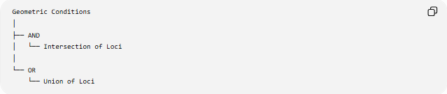
Geometric Conditions
│
├── AND
│ └── Intersection of Loci
│
└── OR
└── Union of Loci

Example: Complete Locus Problem
# Source: AI Source: Provided by: [Data Path: Persons Table -> ID Column: 1, Name_En Column: Motasem Essam] -> From: [ChatGPT] on [7/25/2026]
Problem
Find the locus of $P$such that:
$$PA=4$$
and:
$$PB=PC.$$
Condition 1
$$PA=4$$
gives:
$$L_{1}=\text{circle centered at }A\text{ with radius }4.$$
Condition 2
$$PB=PC$$
gives:
$$L_{2}=\text{perpendicular bisector of }BC.$$
Both conditions
Because both must be satisfied:
$$\boxed{L=L_{1}∩L_{2}}$$
The answer consists of the common point(s) of the circle and perpendicular bisector.

Classification Summary
# Source: AI Source: Provided by: [Data Path: Persons Table -> ID Column: 1, Name_En Column: Motasem Essam] -> From: [ChatGPT] on [7/25/2026]
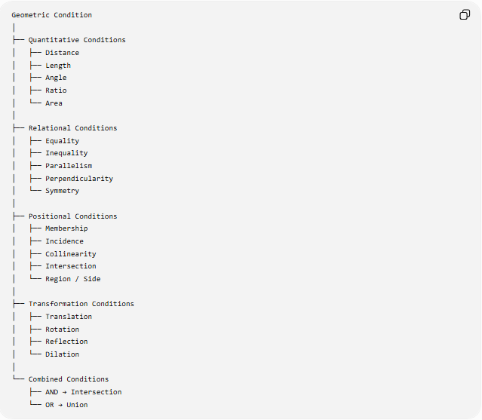
Geometric Condition
│
├── Quantitative Conditions
│ ├── Distance
│ ├── Length
│ ├── Angle
│ ├── Ratio
│ └── Area
│
├── Relational Conditions
│ ├── Equality
│ ├── Inequality
│ ├── Parallelism
│ ├── Perpendicularity
│ └── Symmetry
│
├── Positional Conditions
│ ├── Membership
│ ├── Incidence
│ ├── Collinearity
│ ├── Intersection
│ └── Region / Side
│
├── Transformation Conditions
│ ├── Translation
│ ├── Rotation
│ ├── Reflection
│ └── Dilation
│
└── Combined Conditions
├── AND → Intersection
└── OR → Union

Key Points
# Source: AI Source: Provided by: [Data Path: Persons Table -> ID Column: 1, Name_En Column: Motasem Essam] -> From: [ChatGPT] on [7/25/2026]
- A geometric condition is a requirement that a geometric configuration must satisfy.
- It is the starting point for many geometric problems.
- A geometric condition can involve:
  - distance,
  - length,
  - angle,
  - equality,
  - inequality,
  - ratio,
  - area,
  - position,
  - membership,
  - parallelism,
  - perpendicularity,
  - symmetry,
  - transformations.
- In locus geometry:
$$\boxed{\text{Geometric Condition}→\text{Locus}}$$
- In locus construction:
$$\boxed{\text{Geometric Condition}→\text{Identify Locus}→\text{Construct Locus}}$$
- Multiple conditions can produce an intersection:
$$\boxed{C_{1}∧C_{2}→L_{1}∩L_{2}}$$
- Alternative conditions can produce a union:
$$\boxed{C_{1}∨C_{2}→L_{1}∪L_{2}}$$
- Additional conditions can restrict an existing locus:
$$\boxed{L_{\text{restricted}}=L∩R}$$

Conclusion
# Source: AI Source: Provided by: [Data Path: Persons Table -> ID Column: 1, Name_En Column: Motasem Essam] -> From: [ChatGPT] on [7/25/2026]
A Geometric Condition is the fundamental requirement that determines which geometric configurations or positions are allowed. In locus geometry, the condition is analyzed to determine the set of all points satisfying it.
The central chain is:
$$\boxed{\text{Geometric Condition}→\text{Locus}→\text{Locus Construction}}$$
For multiple conditions:
$$\boxed{\text{AND}→\text{Intersection}} \\ \boxed{\text{OR}→\text{Union}}$$
and for additional restrictions:
$$\boxed{\text{Basic Locus}∩\text{Restriction}→\text{Restricted Locus}}$$
Thus, geometric conditions are the starting point from which loci, locus constructions, intersections, unions, and restricted loci are derived.

